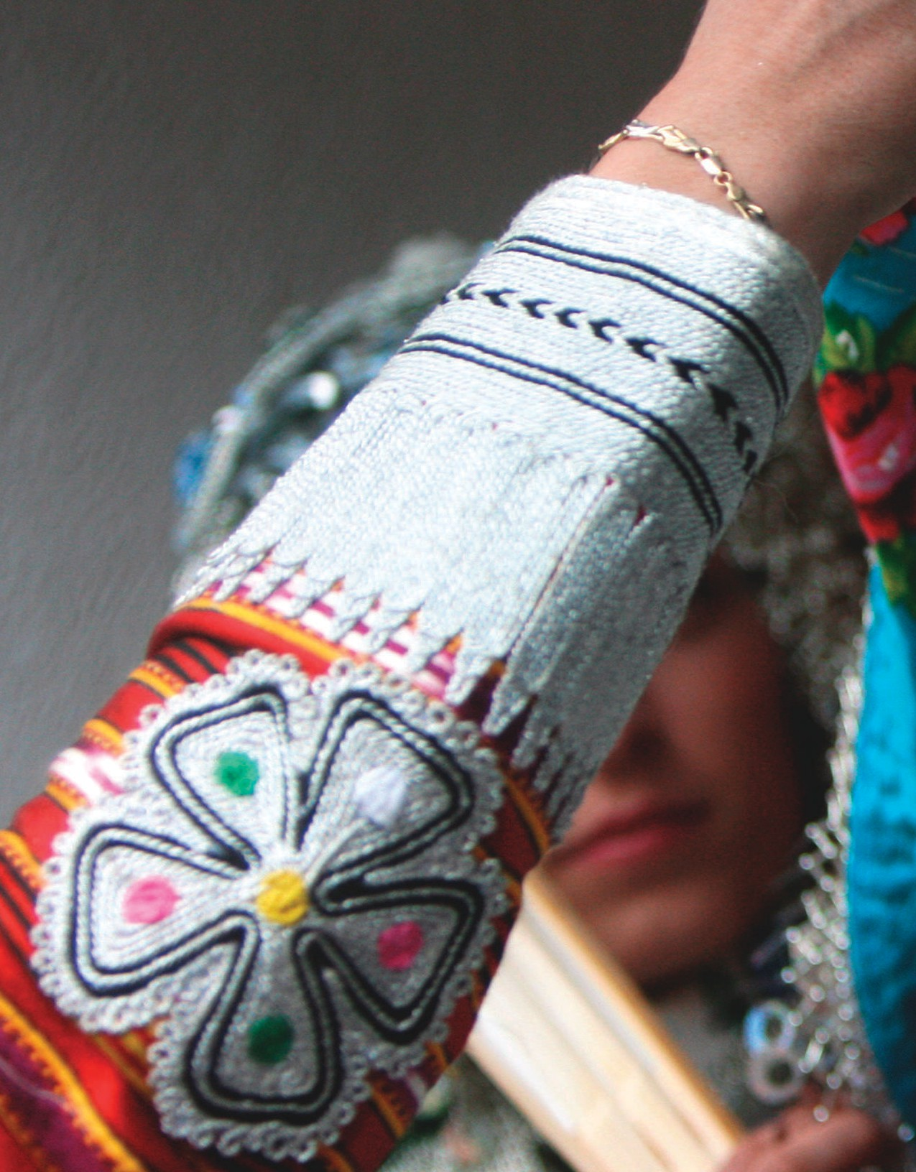
1Customs and Traditions
UNIT

The Present

A bride wears paint on her face to prevent bad luck during a traditional wedding ceremony
in the village of Donje Ljubinje, Kosovo.

Copyright 2015 Cengage Learning. All Rights Reserved. May not be copied, scanned, or duplicated, in whole or in part. Due to electronic rights, some third party content may be suppressed from the eBook and/or eChapter(s).
Editorial review has deemed that any suppressed content does not materially affect the overall learning experience. Cengage Learning reserves the right to remove additional content at any time if subsequent rights restrictions require it.

Lesson 1
page 4
Simple Present: Statements and Questions
Lesson 2
page 12
Present Progressive and Simple Present
Review the Grammar
page 20
Connect the Grammar to Writing
page 22
3

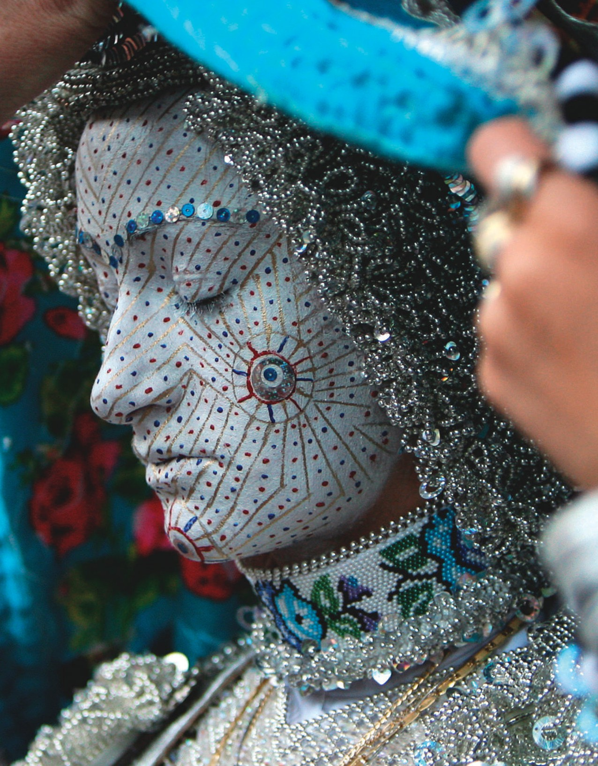
Copyright 2015 Cengage Learning. All Rights Reserved. May not be copied, scanned, or duplicated, in whole or in part. Due to electronic rights, some third party content may be suppressed from the eBook and/or eChapter(s).
Editorial review has deemed that any suppressed content does not materially affect the overall learning experience. Cengage Learning reserves the right to remove additional content at any time if subsequent rights restrictions require it.

Simple Present: Statements and Questions
LESSON 1

EXPLORE


CD1-02
- READ the article about weddings among the Afar people of Djibouti. Notice the words in bold.


























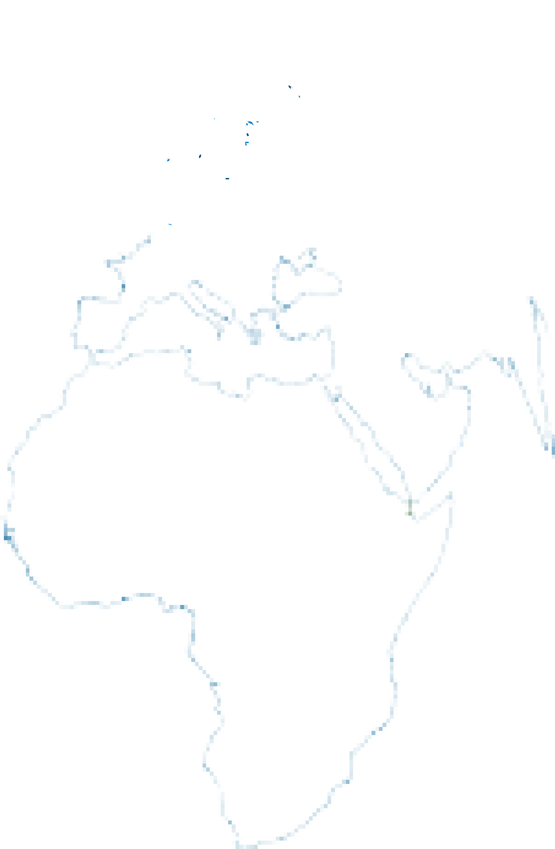









An Afar Wedding

What is an Afar wedding ceremony like?
The actual wedding ceremony is only for men. The bride1 does not go to this ceremony. Instead, her father represents2 her. The women celebrate3 in a different place. They sit and talk about the bride’s life.
The women’s ceremony often includes a lot of dancing.

What happens next?
After these separate ceremonies, the bride and groom4 meet with their families and friends. Sometimes this party lasts all night. The next day, the bride and groom invite their families to their new home.
They eat a traditional5 meal. A typical meal is goat with rice.

What do the bride and groom wear?
Often they both dress in traditional clothes, but the bride sometimes wears a western-style dress. Some brides wear a lot of gold jewelry.

Who pays for the wedding?
In the Afar culture, the man pays for the wedding. He also provides a home for his new wife, but they do not live there together until three days after the wedding.

1 bride: a woman on her wedding day
2 represent: to act in the place of someone
3 celebrate: to have a party or a meal to mark a special occasion
4 groom: a man on his wedding day
5 traditional: based on things that people have done in a certain way for a long time

This Afar bride wears gold jewelry for her wedding.

4 THE PRESENT
Copyright 2015 Cengage Learning. All Rights Reserved. May not be copied, scanned, or duplicated, in whole or in part. Due to electronic rights, some third party content may be suppressed from the eBook and/or eChapter(s).
Editorial review has deemed that any suppressed content does not materially affect the overall learning experience. Cengage Learning reserves the right to remove additional content at any time if subsequent rights restrictions require it.


Many Afar people live in Africa’s Great Rift Valley.

- CHECK. Read the statements. Circle T for true or F for false.
  - The bride and groom go to the wedding ceremony together. T
F
  - Women dance to celebrate the wedding. T F
  - Sometimes the bride does not wear traditional clothing. T F
  - The family eats a traditional meal. T F
  - The bride’s father pays for the wedding. T F

- DISCOVER. Complete the exercises to learn about the grammar in this lesson.
- Look at these sentences from the article in exercise 1. The subject of each sentence is underlined. Write S if the subject is singular. Write P if the subject is plural.
  - S The bride does not go to this ceremony.
  - Instead, her father represents her.

  - The women celebrate in a different place.

  - They sit and talk about the bride’s life.

  - The women’s ceremony often includes a lot of dancing.

- Notice the verbs in bold in the sentences in exercise A. How are the verbs in the sentences with a singular subject different from the verbs in the sentences with a plural subject? Discuss your answer with your classmates and teacher.
UNIT 1 LESSON 1 5

LEARN

Simple Present: Affirmative and Negative Statements
Subject | Verb
I/You/We/They | eat | a lot.
He/She/It | eats | a lot.

Subject | Do Not/Does Not | Base Form
I/You/We/They | do not don’t | eat | a lot.
He/She/It | does not doesn’t | eat | a lot.

    - Use the simple present to talk about:
Contractions are usually used in
conversation and informal writing.
He doesn’t watch TV. We don’t like pizza.
Negative
Affirmative
      - habits and repeated actions
      - facts and general truths
      - how often something happens
    - Be careful! Don’t forget to add -s, -es, or -ies to verbs when the subject is he, she, it, or a singular noun.

- We eat dinner at 7:30.
- The mail doesn’t come on Sundays.
- Jim visits his uncle twice a year.
  - Rosa teaches math.
✗ Rosa teach math.
REAL ENGLISH

See page A1 for simple present spelling rules.

- Complete each sentence with the correct form of the verb in parentheses.
  - At an Afar wedding the families eat (eat) a traditional meal.

  - An Afar bride (not attend) the actual wedding ceremony.

  - The women (dance) during their celebration.

  - The bride and groom (invite) their friends and family to a party.

  - The bride’s parents (not pay) for the wedding.

  - The wedding (not end) on the first day.

  - A groom (provide) a new home for his bride.

  - They (not live) together immediately.

- SPEAK. Work with a partner. Take turns making affirmative or negative statements. Use the subjects and verbs from the chart below.
The groom pays for the wedding. The bride doesn’t go to the wedding ceremony.

Subjects | Verbs
the bride | dance
the wedding guests | eat
the groom | go
the bride’s father | live
they | pay
she | sing
he | wear
- THE PRESENT

Simple Present: Questions and Answers
Yes/No Questions
Short Answers
Do
Does
he/she/it
sing?
Yes, I do. / No, I don’t.
Yes, he does. / No, he doesn’t.
Wh - Questions
Short Answers
Popular songs.
Every Saturday night. They love music.
Her father. Twice a year.
He has a party.
Who or What as Subject
Short Answers
Professor Ortega.
My family.
Base Form
Do/Does Subject
I/you/we/they

Wh- Word | Do/Does | Subject | Base Form
What | do | I | sing?
When |  | you
Why |  | they
Who | does | she | visit?
How often |  | she
How |  | he | celebrate?

Wh- Word | Verb
Who | teaches | this class?
What | makes | you happy?

1. Yes/No questions ask for answers of yes or no. | A: Do you speak Russian?  B: Yes, I do. / No, I don’t.
2. Wh- questions ask for specific information. The answer is a person, place, thing, or other piece of information. | A: Where does Jeff live?  B: In Sydney.
3. Who or What can be the subject in a Wh-question. When Who or What is the subject, the verb is always in the third person singular form (-s/-es form). | A: Who teaches math? (Who = subject) B: Arlene.
4. Be careful! When Who or What is the subject, do not use do or does with the main verb. | - Who teaches this class?  ✗ Who does teach this class?

- Complete each question. Use the words in parentheses and the simple present.
  - Do all brides wear (all brides / wear) white dresses?

  - (what / people / give) the bride and groom?

  - (the bride’s mother / cut) the wedding cake?

  - (the bride and groom / have) a party after the ceremony?
  - (who / the bride / dance) with first?

  - (what / the bride and groom / do) after the wedding?
  - (what / the guests / do) at the wedding?

  - (who / pay) for the wedding?
UNIT 1 LESSON 1 7

- SPEAK. Work with a partner. Take turns asking and answering the questions from exercise 6. In your answers, talk about weddings in your own culture or country.
A: Do all brides wear white dresses?
B: No, they don’t. Some brides wear red dresses.

Frequency Adverbs with the Simple Present
0%
100%
never
rarely/ sometimes seldom/
hardly ever
often/ frequently
usually
always

1. Frequency adverbs are often used with the simple present. They tell how often something happens. | I usually enjoy parties.  I don’t always remember his birthday. Do you sometimes eat at restaurants?
2. Frequency adverbs usually come after the verb be. They usually come before other verbs. | I am sometimes early for class. Jenny isn’t often late.  Wedding guests are usually happy.
3. Sometimes, usually, frequently, or often can come at the beginning or end of a statement. | Brides wear red dresses sometimes. Usually Western brides wear white.
4. Ever is common in questions about frequency. It means at any time. It is not usually used in affirmative statements. | A: Do you ever eat at restaurants? B: No, I never do. / Yes, I often do.

- Rewrite each statement or question using the adverb in parentheses. Place the adverb in a correct position.
  - (usually) I am with friends on my birthday.

I am usually with friends on my birthday.

  - (hardly ever) Marco is on time for parties.

  - (never) My parents forget my birthday.

  - (always) Children aren’t happy at birthday parties.

  - (often) Does your sister send you photos?

  - (sometimes) Jackie buys unusual presents for her family.

8 THE PRESENT

  - (rarely) In the United States, brides wear red dresses.

  - (frequently) I go back to my hometown.

  - (seldom) Carlos talks to his brother on the phone.

  - (ever) Do you visit your cousin in Spain?

































PRACTICE


CD1-03
- Complete the conversation. Use the words in parentheses and the simple present. Then listen and check your answers.
Valerie: Tell me, Kofi . . . How (1) do people usually celebrate
(people / usually / celebrate) birthdays in Ghana?
Kofi: Well, I am Asante, and the Asante people (2) (not celebrate) our birthdays on the date we were born. Instead, we celebrate on the day of the week we were born. It is a special day, called krada. For example, I was born on a Friday, so I (3) (always / wait) until the first Friday after my birthday to celebrate.
Valerie: Oh, that’s interesting. When (4) (krada / start)?
Kofi: In the morning. For the Asante, a new day (5) (never / begin) at midnight. The day (6) (always / start)
at sunrise.
Valerie: What (7) (you / usually / do) to celebrate krada?
Kofi: Well, for children, parents (8) (often / prepare) a special breakfast for krada. They (9) (usually / make) a dish called oto from sweet potatoes and eggs.
They (10) (always / fry) the oto in palm oil. Later in the day, the child has a party. At the party, children
(11) (usually / eat) meat with rice and a sweet dish called kelewele.

- SPEAK. How do people usually celebrate their birthdays in your culture? In your family? Share your answers with a partner.
A: In my country, we usually cook a big meal for our friends. B: Really? That’s a lot of work!
UNIT 1 LESSON 1 9

- Complete the exercises.
  - Read the statements. Then add a frequency adverb from the box to make true statements about yourself and your family. You can use some frequency adverbs more than once.
always ever hardly ever never often rarely seldom sometimes usually

usually
    - We don’t give each other expensive presents.

    - I send my parents a card on their wedding anniversary.

    - We get together as a family.

    - I am late for family parties.

    - My family has big celebrations.

    - My parents are happy to see me.

    - People in my family aren’t quiet during meals.

    - We spend weekends together.

  - Work with a partner. Share your statements from exercise A. Ask and answer questions about your statements.
A: We don’t usually give each other expensive presents.
B: Do you ever give each other expensive presents?
A: Not often. We usually buy something small or go out for dinner.

- EDIT. Read the conversation. Find and correct seven more errors with the simple present and frequency adverbs.

does your family get
Kenji: How often your family does get together?
Raoul: We get together about two or three times a year, but it’s not always easy. My brother lives on the West Coast, and my sister often is away on business trips.
Kenji: So, where you meet when you get together?
Raoul: Well, we go usually to my parents’ house. We tries to get home to celebrate their wedding anniversary every year. Sometimes, my brother and I visit each other on our birthdays. Once every two or three years we take a vacation together. I’d like to do it every year, but it cost a lot of money.
Kenji: Have you a good time with your brother and sister?
Raoul: Oh, yes, most of the time. We have sometimes a few arguments, just like any family.

10 THE PRESENT

LISTEN, WRITE & SPEAK.
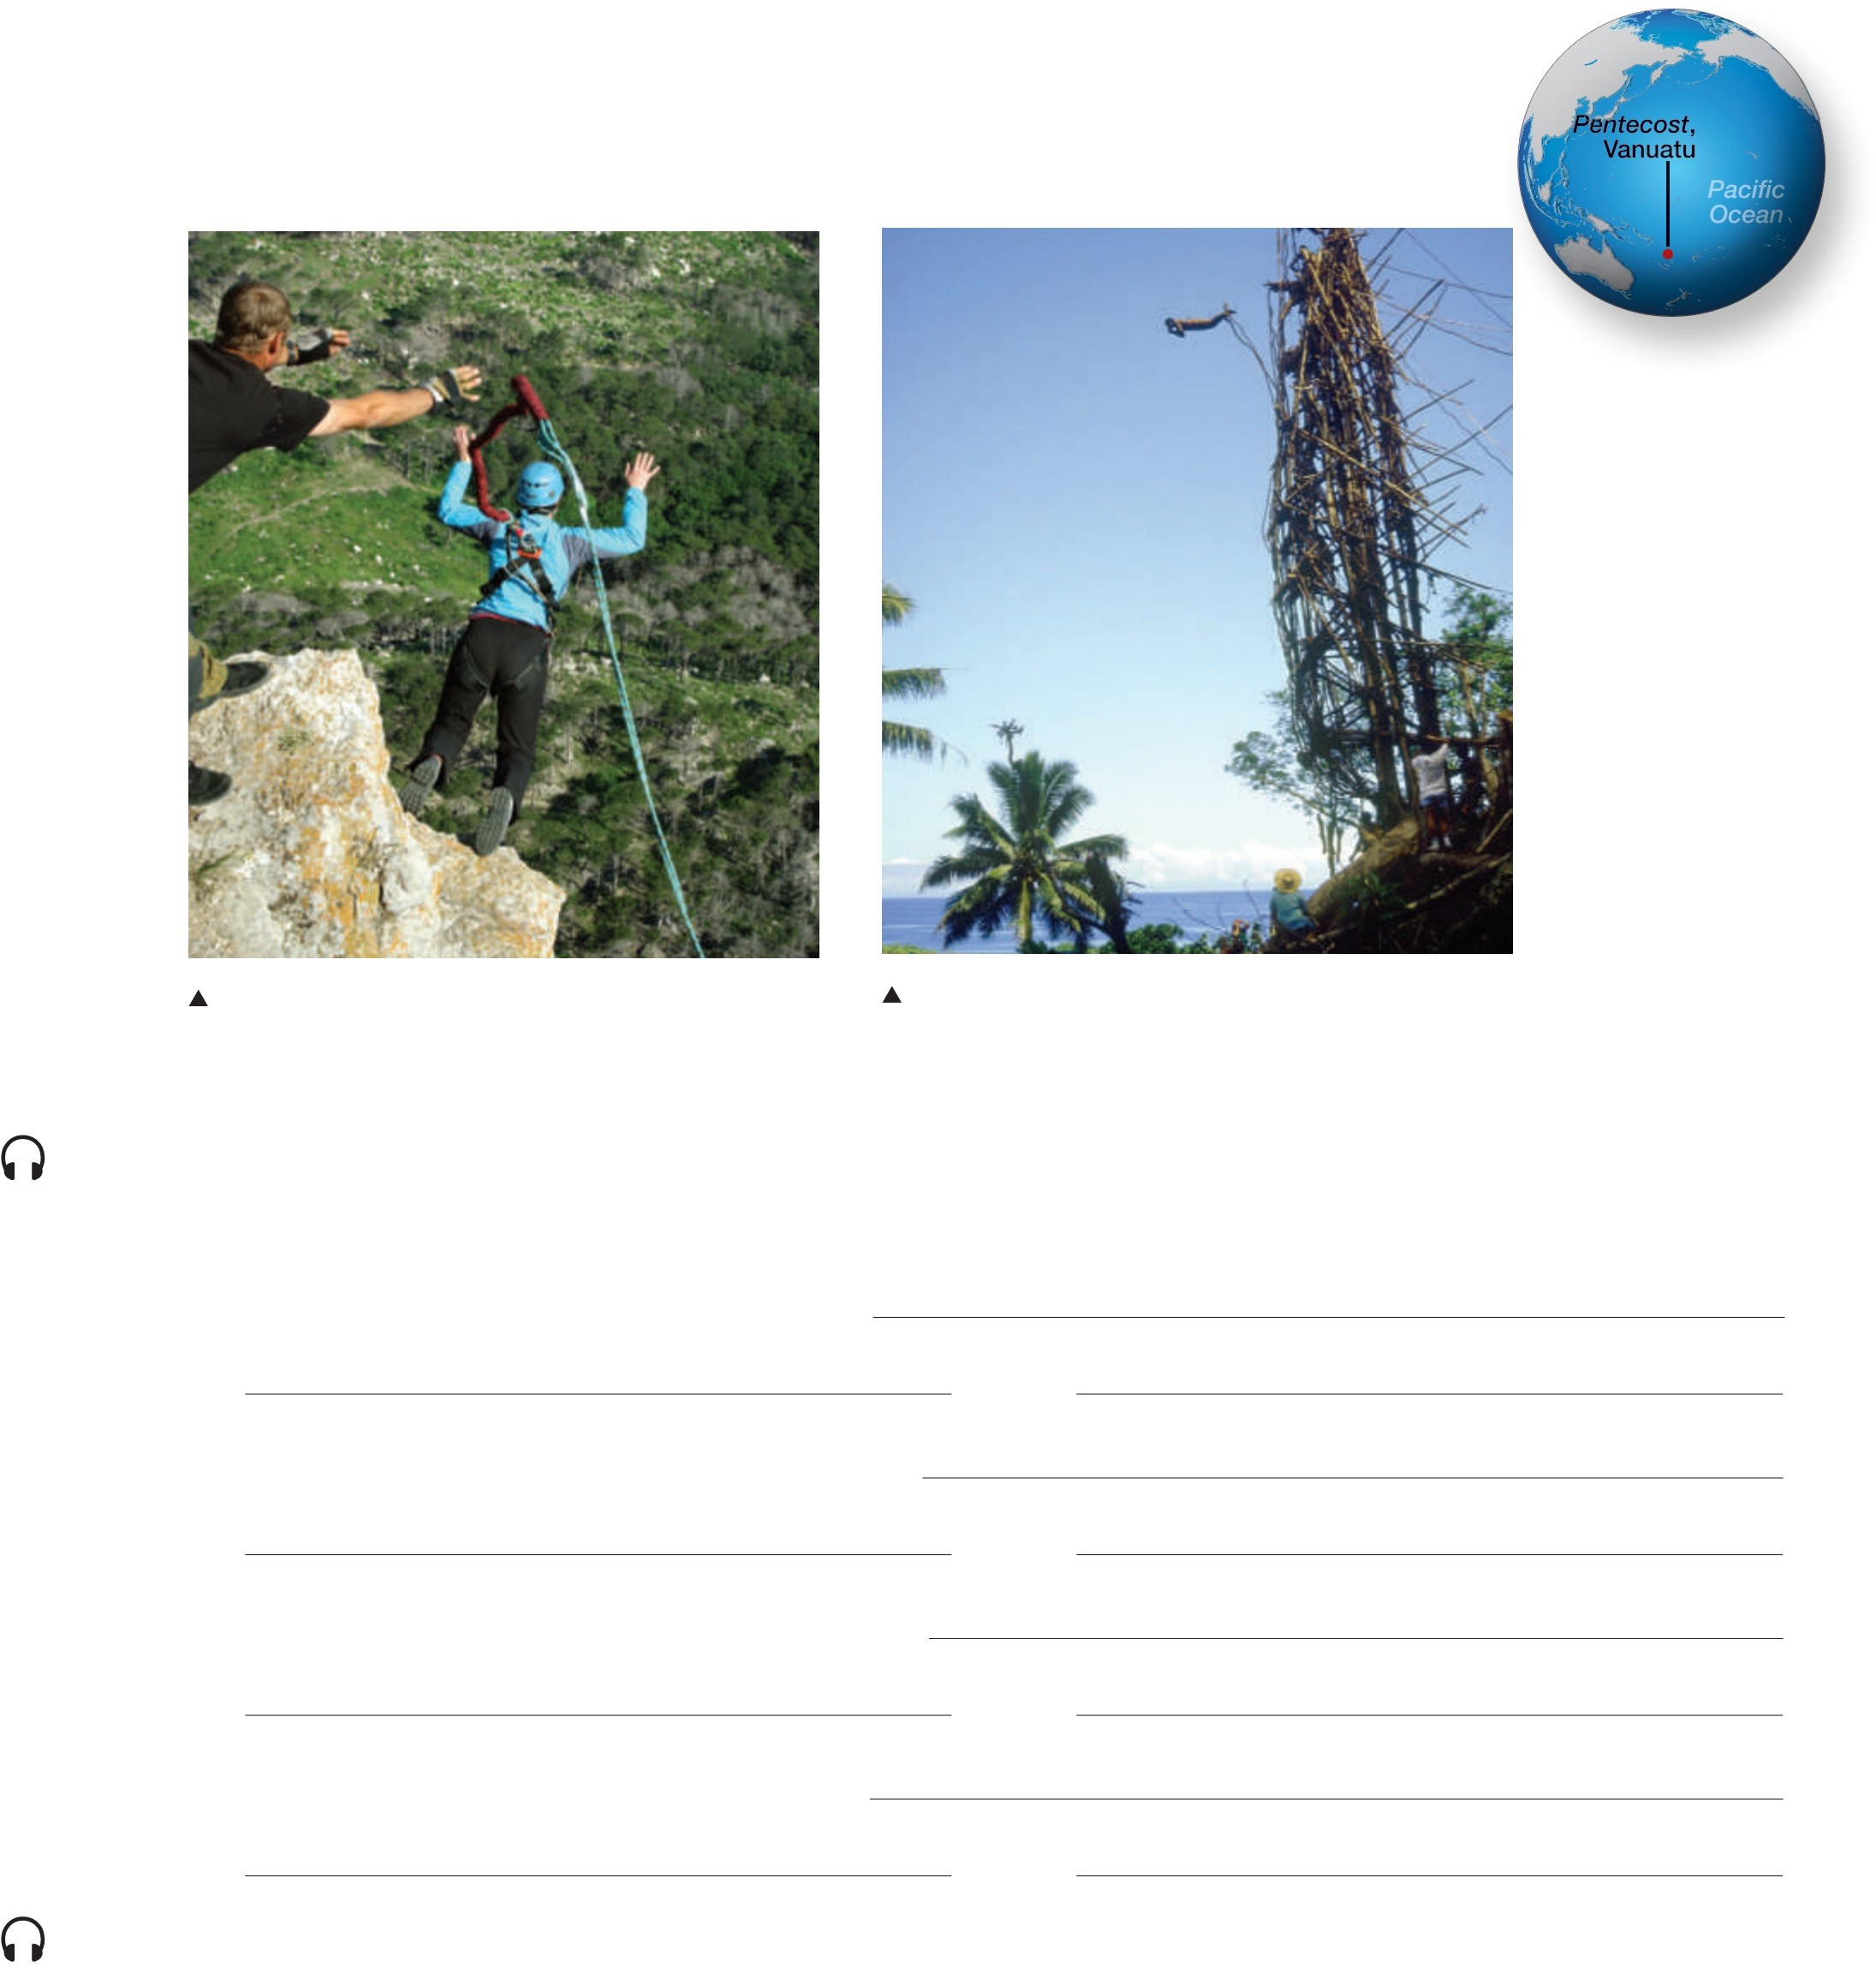
  - Look at the photos and read the captions. Then work with a partner and answer the questions.
    - Where are the people in each picture?
    - What is the name of each activity?
    - Would you like to do these activities? Why, or why not?

Bungee jumping is a popular vacation activity. Here a woman bungee jumps from a cliff in Ukraine.
A boy jumps from a high tower on Pentecost, Vanuatu. This is called land diving. He uses vines as a rope.

CD1-04
  - Put the words in the correct order to make questions. Then listen to the radio show and take notes to help you answer each question.
    - the tower / climb / the boys / do / why

    - the boys / how / jump / do / off the tower

    - digs / the ground / who / below the tower

    - do / the boys / get killed / rarely / why
Notes:

Notes:

Notes:

Notes:

CD1-04
  - Listen to the interview again. In your notebook, write the answers to the questions from exercise B. Then work with a partner and compare your answers.

- APPLY. Work in a small group. How do people in your country celebrate the change from childhood to adulthood? Is there a special ceremony? Discuss your answers.
A: In my country, your 20th birthday is special. It means you’re an adult. We celebrate with a big ceremony.
B: Really? Do you wear special clothes?
A: Yes. Women usually wear traditional clothes. Men usually wear suits and ties.
UNIT 1 LESSON 1 11

Present Progressive and Simple Present
LESSON 2

EXPLORE

CD1-05
- READ the article about Diwali. Notice the words in bold.
Diwali

What are these women doing?
These women in India are getting ready for Diwali. Diwali is an important holiday for Hindus. It is also called the Festival of Lights. Diwali happens in late October or early November every year.

What do Hindus do during Diwali?
People like to have new clothes for Diwali. The women in the photo are wearing new saris.1 They are lighting sparklers and placing them around their home. They want their family to have a successful future. The women hope that the sparklers attract Lakshmi, the Hindu goddess of wealth and success. The star-shaped design on the floor is a rangoli. It also helps to attract the goddess.
Hindus believe that Lakshmi visits people’s homes during Diwali. In the Hindu religion, a visit from Lakshmi is a very good thing. It means a happy future for the family.

¹ sari: a traditional form of dress for women in India and other south Asian countries

These women are lighting sparklers for the festival of Diwali in Jaipur, Rajasthan, India.

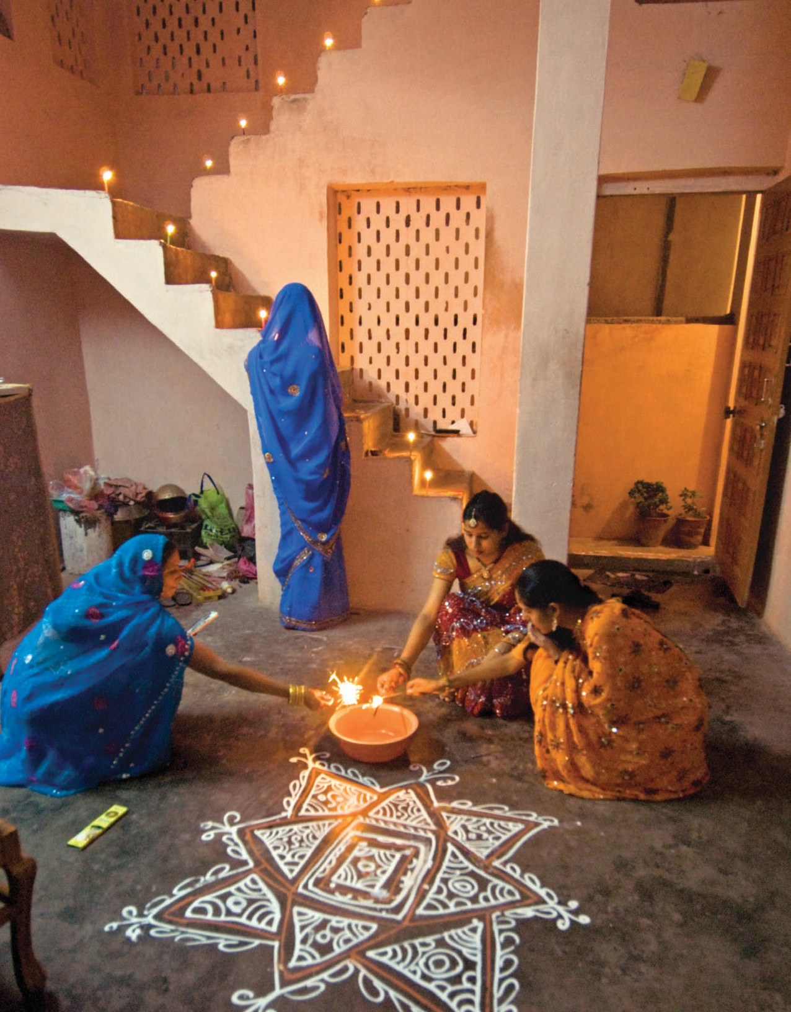

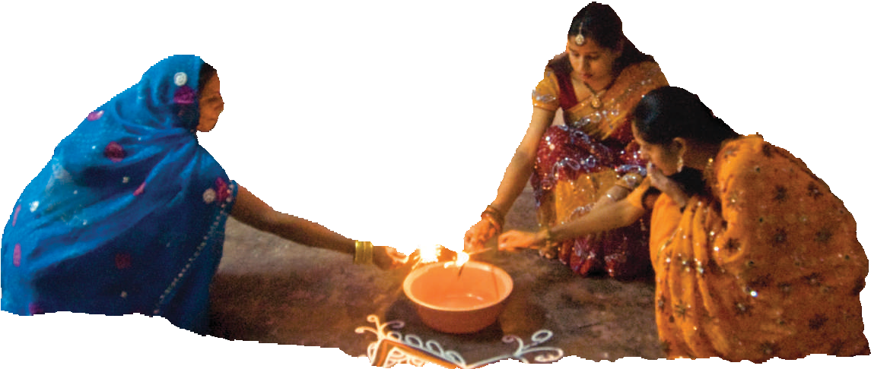

12 THE PRESENT
Copyright 2015 Cengage Learning. All Rights Reserved. May not be copied, scanned, or duplicated, in whole or in part. Due to electronic rights, some third party content may be suppressed from the eBook and/or eChapter(s).
Editorial review has deemed that any suppressed content does not materially affect the overall learning experience. Cengage Learning reserves the right to remove additional content at any time if subsequent rights restrictions require it.


Oil lamps on Diwali
UNIT 1 LESSON 2 13
Copyright 2015 Cengage Learning. All Rights Reserved. May not be copied, scanned, or duplicated, in whole or in part. Due to electronic rights, some third party content may be suppressed from the eBook and/or eChapter(s).
Editorial review has deemed that any suppressed content does not materially affect the overall learning experience. Cengage Learning reserves the right to remove additional content at any time if subsequent rights restrictions require it.

- CHECK. Read the questions. Then write short answers.
  - What is another name for Diwali? the Festival of Lights

  - When does Diwali take place?

  - What are the women in the photograph wearing?

  - Where is the rangoli?

  - Who is Lakshmi?

  - What does a visit from Lakshmi mean?

- DISCOVER. Complete the exercises to learn about the grammar in this lesson.
- Look at these sentences from the article in exercise 1. Check (✓ ) the correct description of each bold verb.

 | Happening Now | Generally True
1. These women in India are getting ready for Diwali. | ✓
2. People like to have new clothes for Diwali.
3. The women in the photo are wearing new saris.
4. They are lighting sparklers . . .
5. They want their family to have a successful future.
6. The women hope that the sparklers attract Lakshmi . . .

- Work with a partner. Compare your answers from exercise A. What do you notice about the verb form that describes actions that are happening now?

LEARN

Present Progressive: Affirmative and Negative Statements
Affirmative
Negative
Subject | Be | Verb + -ing
I | am ’m | studying.
He/She/It | is ’s | working.
You/We/They | are ’re | eating.

Subject | Be + Not | Verb + -ing
I | am not ’m not | studying.
He/She/It | is not  ’s not / isn’t | working.
You/We/They | are not  ’re not / aren’t | eating.

- Use the present progressive* to talk about:  - actions in progress now, at the moment of speaking  - actions in progress at the present time, but maybe not at the moment of speaking | - Look! They’re dancing in the street.  - My class is studying world history this semester.
- Remember: Use the simple present to talk about:  - habits and repeated actions  - facts and things that are generally true  - how often something happens | - Dave and I often take a walk after dinner.  - It snows a lot in Finland.  - I meet with my boss twice a week.
3. Some adverbs and time expressions commonly used with the present progressive are: now, at the moment, this year, and these days. | It is raining at the moment.  Susie is working hard these days.

* The present progressive is sometimes called the present continuous. See page A1 for spelling rules for the -ing form of verbs.

- Complete each sentence with the present progressive form of the verb in parentheses.
  - The women are lighting (light) sparklers.

  - They (draw) pictures on the floor.

  - Usha (not / celebrate) the holiday with her family.

  - She (study) in England this year.

  - I (not prepare) the food for the party.

  - Alberto (help) in the kitchen at the moment.

  - He (wash) the dishes right now.

  - We (get) the house ready for the party.

- Circle the correct form of the verb to complete each sentence.
  - Thousands of people attend / are attending the festival this year. The hotels are full!
  - Every November people celebrate / are celebrating a special holiday in Mexico.
  - My grandmother usually organizes / is organizing the celebrations in my family.

14 THE PRESENT

  - The Chinese New Year marks / is marking the end of the winter season.
  - Right now I make / am making a cake for the party.
  - My father makes / is making beautiful cakes to celebrate special events.
  - We have / are having a party for my grandparents every summer.
  - Everyone dances / is dancing right now.

Present Progressive: Questions and Answers
Yes/No Questions
Short Answers
Am Is
Are
helping?
you
Yes, you are. / No, you’re not.
Yes, he is. / No, he’s not.
Yes, we are. / No, we’re not.
Wh - Questions
Answers
You’re studying.
He’s singing.
They’re cooking.
She’s watching a sad movie.
Who or What as Subject
Short Answers
Her father.
John’s leaving.
1. Remember: Who or What can be the subject in a Wh- question. When Who or What is the subject, the verb is always in the third person singular form (-s/-es form).
A: Who’s playing the piano? B: Marta.
Subject Verb + -ing
Be
he
I

Wh- Word | Be | Subject | Verb + -ing
What | am | I | doing?
 | is | he
 | are | they
Why | is | she | crying?

Wh- Word | Be | Verb + -ing
Who | is | dancing | with Carmen?
What |  | happening?

- Use the words in parentheses to complete the questions or answers. Use the present progressive.
  - A: Hi, Ana. (1) What are you doing (what / you / do)? B: I (2) (buy) a plane ticket online.
  - A: (3) (where / you / live) these days? B: I (4) (rent) an apartment near the university.
  - A: (5) (why / your computer / make) a noise? B: (6) (it / not work) properly.
  - A: (7) (your phone / ring)?
B: Yes, it is. Thanks. My (8) (brother / call) me.

UNIT 1 LESSON 2 15

- SPEAK. Work with a partner. Ask and answer the questions in numbers 1 and 2 in exercise 6. Use your own answers, not the answers in the book.

Action and Non-Action Verbs

1. Action verbs describe physical or mental actions. | Action: She studies hard every night. Non-Action: I want to go to the dance.
- Non-action* verbs do not describe actions. They describe states, conditions, or feelings. Here are some common categories of non-action verbs:  - Feelings: dislike, hate, like, love, miss  - Senses: feel, hear, see, smell, sound, taste  - Possession: belong, have, own  - Appearance: appear, look, seem  - Desires: hope, need, prefer, want  - Mental States: believe, think, understand | - I love to dance.  - The soup smells delicious.  - He doesn’t own a car.  - Ted looks tired today.  - I want some coffee.  - She understands Japanese.
3. Non-action verbs are not usually used in the progressive. | - They own a house and an apartment.  ✗ They are owning a house and an apartment.
4. It is possible to use the progressive form with some non-action verbs, but their meaning changes. Some common examples are: have, think, look, smell, and taste. | Non-Action Action  He has a headache. He is having lunch.  I think this book is great. I am thinking of the  answer.  The food tastes good. She is tasting the food.

* Non-action verbs are sometimes called stative verbs.

- Complete the conversations with the verbs in parentheses. Use the simple present or the present progressive.
  - Eric: (1) Do you like (like) your new home in Italy?
Jane: Yes, I really (2) (love) it, but I (3) (think) about the United States a lot.
Eric: What (4) you (miss) most?
Jane: Oh, family get-togethers, probably.

  - Sally: Why is Nikki taking so long at the bakery?
Christina: She (5) (taste) the different kinds of cakes.
She (6) (want) the perfect cake for her wedding.

  - Mark: That’s a nice camera.
Tim: Thanks, but it (7) (not / belong) to me. It’s my sister’s. Mark: (8) you (have) your own camera? Tim: No, I (9) (not own) a camera.
  - Maria: (10) you (have) fun tonight?
Barbara: Not really, I (11) (have) a headache.

16 THE PRESENT

PRACTICE
- Look at the photos and read the captions. Then complete the conversation with the words in parentheses. Use the simple present or the present progressive form of the verbs.

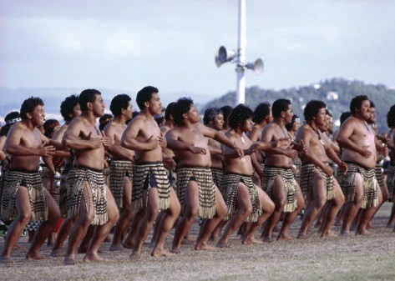

The New Zealand rugby team does the haka before a match.
Maori dancers from New Zealand perform the haka, a traditional war dance.

Todd: Hey, Steve, (1) what are you doing (what / you / do)?
Steve: (2) (I / read) a magazine. Look at this photo of the New Zealand rugby team . . . (3) (they / look) scary!
Todd: (4) (what / they / do)?
(5) (they / dance)?
Steve: (6) (they / perform) the haka. It’s a Maori war dance.
Todd: (7) (they / do) it before every game?
Steve: Yes. (8) (it / help) them get ready for the game mentally, and (9) (they / believe) that it frightens the other team.
Todd: Interesting. (10) (it / work)?
Steve: Maybe in the past, but (11) (it / never / surprise) anyone now. (12) (the other team / usually / pay) no attention. But, (13) (the fans / love) it, and (14) (the haka / always / provide) an opportunity for great photos!

WRITE & SPEAK.
- Use the words to make Yes/No and Wh- questions. Use the simple present or the present progressive.
  - what holidays / you / enjoy What holidays do you enjoy?

  - what / your classmates / do / right now

  - what / you / want / for your birthday

UNIT 1 LESSON 2 17

  - you / do / anything interesting / these days

  - you and your friends / like / soccer

  - you / often / work / on weekends

  - what / your class / study / this week

  - where / you / usually / have / lunch

- Work with a partner. Ask and answer the questions from exercise A.
A: Which national holidays do you enjoy? B: I like Thanksgiving. How about you?


CD1-06
- Complete the conversations with the words from the box. Use the simple present or present progressive. Then listen and check your answers.

do | have | not believe | not look | talk | think
hate | need | not feel | not want | taste

Conversation 1
Midori: Hi Sally, how (1) are you doing ?
Sally: I’m OK. You?

Midori: Great. You know, I usually (2) big crowds, and
I (3) people are too noisy in big groups. Well, guess what: right now I’m in New York City at the Thanksgiving Day parade!
Sally: You are? I (4) it!
Midori: Yes, I am! And I (5) a wonderful time!

Conversation 2
Angela: Mmm . . . this soup (6) delicious! Do you want some?
Kara: No, thanks.
Angela: Are you sure? It’s really good.
Kara: No, thanks. I (7) well, and I (8) you to get sick.

Conversation 3
Mike: Hi, Kemal. Are you OK? You (9) very happy. What’s the matter?
Kemal: Oh, I . . .
Andy: Hey, Mike, do you have a minute? I (10) to ask you something.
Mike: Sorry, but Kemal and I (11) right now. Can I talk to you later?

18 THE PRESENT

READ & WRITE.
- Read the paragraph. Underline the verbs in the simple present and circle the frequency adverbs.
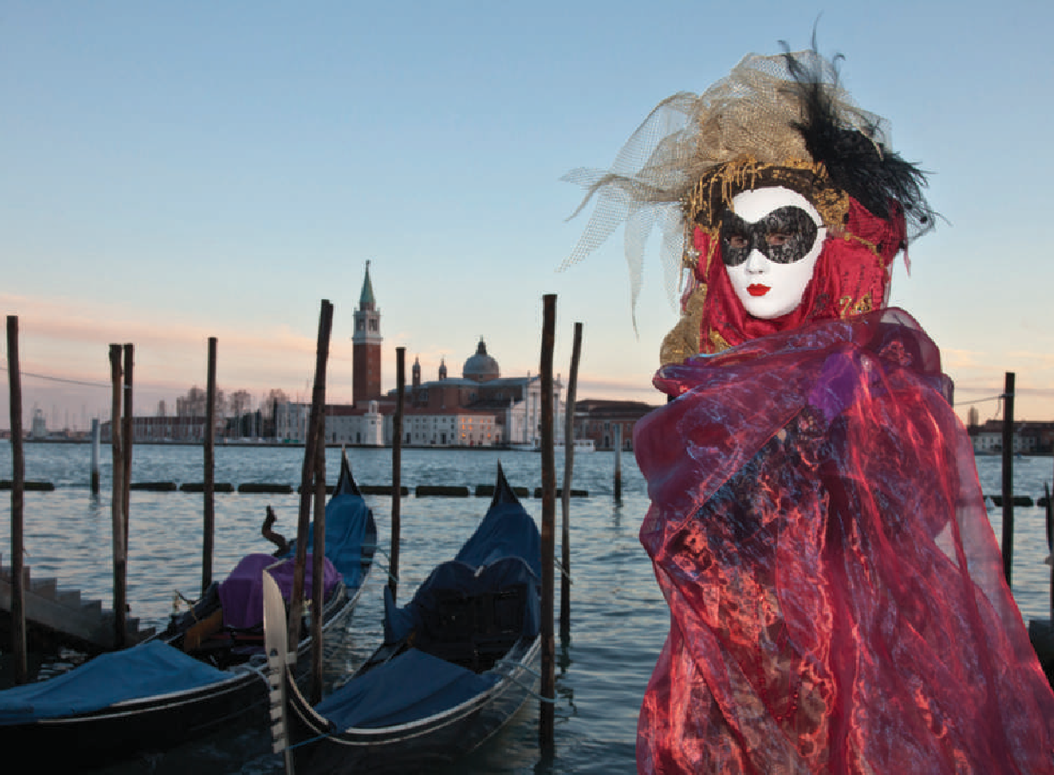

A Carnival costume, Venice, Italy
I come from Venice, Italy, and I really love my city. My favorite time of year is Carnival. People wear masks and beautiful costumes and parade through the streets. My family and I always have a little competition to see who has the best costume. My sister is in art school, so she usually wins.
The rest of us compete for second prize!
- In your notebook, write a paragraph of five or six sentences about an event in your country or culture. Use the simple present and frequency adverbs.

APPLY.
- Write questions to ask a classmate about what he or she is doing this week, this month, this semester, or this year. Use the present progressive.

Questions | Answers
Where are you living these days?

- Work with a partner. Take turns asking and answering your questions from exercise A. Take notes on your partner’s answers in the chart.

- Tell the class about your partner. Use the information from the chart in exercise A.
UNIT 1 LESSON 2 19

Charts 1.1–1.6
Review the Grammar UNIT 1
- Complete the conversation with the words in parentheses. Use the simple present or the present progressive.
Silvana: Hey Christine, it’s the 4th of July . . . (1) Why are you siting (why / you / sit) here in the library?
Christine: I (2) (work). I (3) (have) an important assignment to finish.
Silvana: But Americans (4) (always / celebrate) Independence Day!
Christine: Well, things are different this year. I (5) (usually / visit)
my brother and sister, and we (6) (have) a barbecue, but they’re not around this year.
Silvana: Oh, (7) (what / they / do) this year?
Christine: Matt (8) (take) a computer course in San Francisco, and my sister Denise (9) (work). She’s a doctor.
Silvana: Oh, that’s too bad!
Christine: Yeah, and she often (10) (work) on weekends and holidays.
Silvana: Well, listen, I (11) (not do) anything special today.
(12) (you / want) to get something to eat later?
Christine: Great idea! I (13) (hear) the new Thai restaurant on Tucker Street is really good. (14) (you / like) Thai food?
Silvana: I (15) (love) Thai food! Give me a call when you are ready.

Charts
1.1, 1.3, 1.4
- EDIT. Read the paragraph about La Tomatina. Find and correct five more errors with the simple present, the present progressive, and frequency adverbs.

La Tomatina

organize
In my town, Buñol, Spain, the local people are organizing a festival called La Tomatina every year. It always is starting on the last Wednesday in August, and it last for a week. La Tomatina is a food fight. Every summer, thousands of local people and visitors gets together to throw tomatoes at each
other. Yes, that’s right—tomatoes! And I’m not talking about just a few tomatoes. La Tomatina is using around a hundred tons
of tomatoes every year. These days the festival is becoming so

20 THE PRESENT
popular that other countries start to organize their own events similar to La Tomatina.
A man lies in tomatoes at La Tomatina in Sutamarchán, Colombia.

Copyright 2015 Cengage Learning. All Rights Reserved. May not be copied, scanned, or duplicated, in whole or in part. Due to electronic rights, some third party content may be suppressed from the eBook and/or eChapter(s).
Editorial review has deemed that any suppressed content does not materially affect the overall learning experience. Cengage Learning reserves the right to remove additional content at any time if subsequent rights restrictions require it.

Charts 1.1–1.6

CD1-07

Charts 1.1–1.6
- LISTEN to an excerpt from a lecture about La Tomatina. Write the missing words.
Professor: . . . Now, let’s look at the next slide, and you will see what (1) I am talking about.
Yes, there we are. Now, look at the young man in this photo.
(2) in tomatoes almost up to his waist. And do you see what’s happening . . . ?
Student 1: (3) more tomatoes at him!
Professor: Yes, Kim, that’s right. And he’s smiling about it.
Student 1: Are you sure? (4) he’s smiling.
Professor: Hmm . . . well, I guess you’re right. But (5) he is complaining?
Student 1: No, (6) to get away. He’s just waiting for the tomatoes to hit him.
Professor: Yes, that’s right. (7) a good time.

Student 2: So, (8) us that people actually do this for fun? They get covered in tomatoes! What’s the point of that?
Professor: You know, Philip, that’s a very good question. We live with so many laws and rules. . . . Sometimes, (9) to feel that there are no rules. Many ancient celebrations (10) a time like this. For a few hours or a couple of days, no one (11) to obey the usual rules. I mean, you can’t just go to Buñol and start throwing tomatoes in January, right?
- SPEAK. Work in a small group. Discuss your answers to these questions.
  - Does La Tomatina sound like something you would like to go to? Why, or why not?

  - Tell the other members of your group about a special festival or celebration in your town or city.




La Tomatina, Buñol, Spain

UNIT 1 REVIEW THE GRAMMAR 21
Copyright 2015 Cengage Learning. All Rights Reserved. May not be copied, scanned, or duplicated, in whole or in part. Due to electronic rights, some third party content may be suppressed from the eBook and/or eChapter(s).
Editorial review has deemed that any suppressed content does not materially affect the overall learning experience. Cengage Learning reserves the right to remove additional content at any time if subsequent rights restrictions require it.

READ & NOTICE THE GRAMMAR.
Connect the Grammar to Writing
      - Does your culture have any traditional sports events? Discuss the event(s) with a partner.
Then read the text.
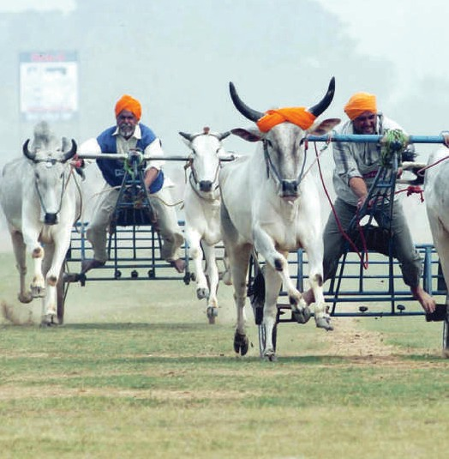
The Kila Raipur Sports Festival
In February, my family and I usually go to the Kila Raipur Sports Festival. Kila Raipur is a town near my home in India.
It’s January now, and we are planning our trip. We are looking forward to this tradition. Each year, thousands of people attend the festival.
At the festival, people race huge tractors.1 Men sometimes lift bicycles with their teeth. In this photo, men are racing carts pulled by oxen. This is everyone’s favorite event.
1 tractor: a vehicle that a farmer uses to pull machinery
GRAMMAR FOCUS
In the text in exercise A, the writer uses the simple present to talk about repeated activities and events and facts.
In February, my family and I usually go to the Kila Raipur Sports Festival. Kila Raipur is a town near my home in India.
At the festival, people race huge tractors. Men sometimes lift bicycles with their teeth.

      - Read the text in exercise A again. Underline the verbs in the simple present. Circle the frequency adverbs. Then work with a partner and compare your answers.
      - Complete the chart with information about the Kila Raipur Sports Festival.
What
Who

Kila Raipur Sports Festival
Where
When
every year

22 THE PRESENT
Copyright 2015 Cengage Learning. All Rights Reserved. May not be copied, scanned, or duplicated, in whole or in part. Due to electronic rights, some third party content may be suppressed from the eBook and/or eChapter(s).
Editorial review has deemed that any suppressed content does not materially affect the overall learning experience. Cengage Learning reserves the right to remove additional content at any time if subsequent rights restrictions require it.

Write about a Tradition
WRITING FOCUS
Capitalizing Proper Nouns
Proper nouns are the names of specific people, places, and things. Some examples of proper nouns are the names of:
- streets, cities, states, countries, and continents
- days of the week, months, and holidays
- people and special events
In February, my family and I usually go to the Kila Raipur Sports Festival. Kila Raipur is a town near my home in India.

BEFORE YOU WRITE.
      - Complete the chart with information about a traditional sports event in your culture. Use the chart from exercise 1C as a model.
When
Where

Who
What

      - Look at the information in your chart from exercise A. Place a 1 next to information that you want to include in your first paragraph. Place a 2 next to information that you want to include in your second paragraph.

    - WRITE two paragraphs about a traditional sports event in your culture. Use the information from your chart in exercise 2A and the text in exercise 1A to help you.

    - SELF ASSESS. Read your paragraphs and underline the simple present and circle the frequency adverbs. Then use the checklist to assess your work.
 I used the simple present for facts. [1.1]
 I used the simple present for repeated actions and events. [1.1]  I put the frequency adverbs in the correct place. [1.3]
 I capitalized proper nouns. [WRITING FOCUS]

UNIT 1 CONNECT THE GRAMMAR TO WRITING 23
Copyright 2015 Cengage Learning. All Rights Reserved. May not be copied, scanned, or duplicated, in whole or in part. Due to electronic rights, some third party content may be suppressed from the eBook and/or eChapter(s).
Editorial review has deemed that any suppressed content does not materially affect the overall learning experience. Cengage Learning reserves the right to remove additional content at any time if subsequent rights restrictions require it.

